RESOLUTION NO.__________

RE: CERTIFICATE OF APPROPRIATENESS UNDER THE
PROVISIONS OF THE ACT OF THE PENNSYLVANIA
LEGISLATURE 1961, JUNE 13, P.L. 282 (53
SECTION 8004) AND BETHLEHEM ORDINANCE NO.
3952 AS AMENDED.

WHEREAS, it is proposed to install a new sign on the rear façade of the building at 21 East Third Street.

NOW, THEREFORE, BE IT RESOLVED by the Council of the City of Bethlehem that a Certificate of Appropriateness is hereby granted for the proposal.

Sponsored by: (s)

(s)

ADOPTED BY COUNCIL THIS DAY OF

(s)
President of Council

ATTEST:

(s)
City Clerk

HISTORIC CONSERVATION COMMISSION

CASE #640 -- It is proposed to install a new sign on the rear façade of the building at 21 East Third Street.
OWNER/APPLICANT: Cleo Smith and John Saraceno/Derrick Clark

The Commission upon motion by Mr. Cornish and seconded by Mr. Hudak adopted the proposal that City Council issue a Certificate of Appropriateness for the proposed work described herein:

- The proposal to install a new sign on the rear (north) façade at of the building at 21 East Third Street was presented by Derrick Clark.
- The proposed sign will be re-located from a previous business location; sign to match material, font style and colors of signage already approved by HCC for the front (south) façade of the new business location.
- The installer of the new sign will take advantage of existing mortar joints for needed fasteners.
- The motion for the proposed work was unanimously approved.

JBL: jbl
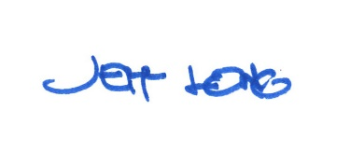

By:

Date of Meeting: February 26, 2018 Title: Historic Officer

